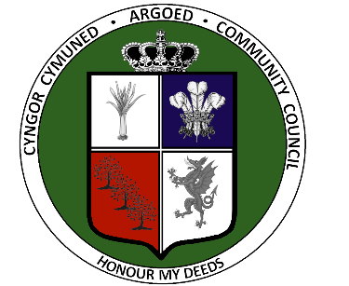

Members of Argoed Community Council

31 December 2025

Dear Councillor

You are requested to attend the meeting of Argoed Community Council to be held at Caffi Isa and via Teams on Wednesday 14 January 2026 at 7:00pm.

Yours sincerely

Clerk & Responsible Finance Officer

AGENDA

- APOLOGIES FOR ABSENCE

- DECLARATIONS OF INTEREST
Members are reminded of their responsibility to declare any personal interest or personal and prejudicial interest, which they have in any item of business on the agenda no later than when that item is reached during the meeting.

- TEN MINUTE PUBLIC PARTICIPATION SESSION
To allow any members of the public who attend to speak or to note any questions raised in writing or by email.

- MINUTES OF PREVIOUS MEETINGS
Confirmation of the accuracy of the minutes of the Council Meeting of 2 December 2025.

- REPORT FROM COUNTY COUNCILLOR
To receive a report and responses on questions asked.

- REPORT FROM REPRESENTATIVES ON OUTSIDE BODIES
To receive any reports.

- MATTERS ARISING
To update Council on matters following on from actions agreed at previous meetings.

- POLICE MATTERS
Assistant Clerk will present a summary of reported crimes for the ward as per the North Wales Police website www.northwales.police.uk/police-forces/north-wales-police/areas/stats-and-data/stats-and-data/.

Members will be asked to pass a resolution for agenda item 9 to exclude the press and public from this item due to the confidential nature of items being discussed.

- HR & COUNCILLOR MATTERS

- CORRESPONDENCE AND CLERK REPORT
Correspondence since the last meeting and other matters that the Clerk needs to raise.

- DRAFT COUNCIL PRIVACY NOTICE
The Clerk will present the draft Council Privacy Notice for approval.

- PRECEPT 2026-27
To discuss the precept requirement and draft budgets prepared for 2026-27.
- BANK RECONCILIATION AND FINANCIAL REPORTS
Clerk to present the bank reconciliation for 31 December 2025 and any other financial reports.

- PLANNING MATTERS
To discuss any planning matters:

PLANNING APPLICATION CONSULTATION - Ref No: FUL/001078/25
PROPOSAL: RETROSPECTIVE APPLICATION REQUIRED FOR SINGLE STOREY REAR AND SIDE EXTENSIONS AND ALTERATIONS TO PROVIDE AN OPEN PLAN KITCHEN, DINING / LIVING AREA AND BEDROOM WITH EN-SUITE SHOWER ROOM
LOCATION: 19, Llewelyn Drive, Bryn Y Baal, Mold, CH7 6SW

15. HIGHWAYS MATTERS
To discuss any traffic matters, including any updates about the bus stops on Mold Road.

16. ACCOUNTS FOR PAYMENT
To consider and approve the accounts for payment and to provide authorisation for monthly payments made by direct debit.

