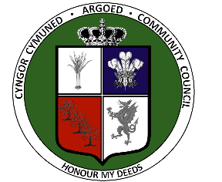
Public Audit (Wales) Act 2004 Section 29
Accounts and Audit (Wales) Regulations 2014

1. The audit of accounts for the Argoed Community Council for the years ended 31 March 2020 and 2021 have been concluded.

- The annual return is available for inspection by any local government elector for the area of the Argoed Community Council on application to:

Clerk@argoedcommunitycouncil.gov.uk
Clerk at Argoed Community Council,
Mynydd Isa Community Centre,
Mercia Drive,
Mynydd Isa,
Flintshire CH7 6UH

between 10.30am and 4 pm on Mondays to Fridays

(excluding public holidays), when any local government elector may make copies of the annual return.

3. Copies will be provided to any local government elector on payment of

£1 for each copy of the annual return.
Mared Eastwood, Clerk and RFO for Argoed Community Council
3 May 2022

Public Audit (Wales) Act 2004 Section 29
Rheoliadau Cyfrifon ac Archwilio (Cymru) 2014

1. Mae archwiliadau cyfrifon dros Cyngor Cymuned Argoed ar gyfer y blynyddoedd Sy’n gorffen ar 31 Mawrth 2020a 2021 wedi’u cwblhau.

- Mae’r cofnod blynyddol ar gael i’w arolygu gan etholwyr llywodraeth leol ardal Cyngor Cymuned Argoed trwy wneud cais at:
Clerk@argoedcommunitycouncil.gov.uk
Clerk at Argoed Community Council,
Mynydd Isa Community Centre,
Mercia Drive,
Mynydd Isa,
Flintshire CH7 6UH

rhwng 10.30 a 4 pm ar ddydd Llun i ddydd Gwener

gan eithrio gwyliau cyhoeddus), pryd y gall unrhyw etholwr llywodraeth leol wneud copïau o’r cofnod blynyddol

3. Darperir copïau i unrhyw etholwr llywodraeth leol os gwneir taliad o

£1 am bob copi o’r ffurflen flynyddol

Mared Eastwood, Clerk and RFO for Argoed Community Council

3 May 2022

