13 May 2021

To: Members of the Amenities Committee

You are hereby summoned to a remote meeting of the Amenities Committee, to be held on Wednesday, 19 May 2021 at 6 p.m.

AGENDA

- Apologies

- Declarations of interest

- Quarry

- Dog-waste bin update

- 5 year plan suggestions

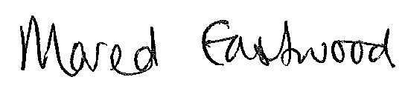
Mared Eastwood
Clerk and RFO

