Andrew Farrow
Chief Officer (Planning & Environment)
Prif Swyddog (Cynllunio a’r Amgylchedd)

 | Your Ref/Eich Cyf
 | Our Ref/Ein Cyf
 | Date/Dyddiad | 20th April 2017
 | Ask for/Gofynner am
 | Direct Dial/Rhif Union
 | Fax/Ffacs
 | E-mail/e-bost

Open space land within your responsibility for inclusion in
A consultation on the Implementing of a Dog Control
Public Spaces Protection Order (PSPO) in Flintshire

Flintshire County Council is intending to consult on a proposed Dog Control Public Spaces Protection Order (PSPO) to cover the whole County.

PSPOs are intended to prevent individuals or groups committing anti-social behaviour in a public space where the behaviour is having, or is likely to have, a detrimental effect on the quality of life of those in the locality, is, or is likely to be, persistent or continuing in nature, and is, or likely to be, unreasonable.

The proposed prohibited activities agreed by the Council to be included in the Dog Control PSPO are summarised below, any breaches would result in the issuing of a Fixed Penalty Notice to the offender.

- Dog faeces must be removed immediately from all public land.
- A dog owner may be asked to place their dog on a lead, if requested, by an authorised officer, if the dog is causing nuisance or harassment to another dog, person or animal at any public location (there is NOT a requirement for dogs to be kept on a lead at all times in public areas)
- Dogs to be excluded from the playing areas of marked sports pitches, designated sporting areas (bowling greens, tennis courts), fenced equipped children’s play areas and School Grounds.
- Dogs to be kept on a lead in Cemeteries.
- Dog walkers to have on their person a means of collecting dog waste if asked by an authorised officer.

The PSPO is necessary to replace the current Dog Control Order which will cease in October 2017, and will last for an initial period of 3 years.

This matter will be open to consultation from 1st June 2017 and the County Council is currently developing a list of sites within its ownership that will be included in the order.

The purpose of this letter is to enquire if there are any ‘Public space’ sites that fall within your responsibility (either owned or leased) that you would like to nominate to be included in the consultation exercise, which would allow enforcement action to be taken against any individual allowing their dog to contravene any of the above orders.

There will be no costs associated with the order for the Town and Community Councils and the cost of the enforcement patrols will be recovered through the income from any fixed penalty notices issued. There will some minimal costs in respect of any signage required by the Town and Community Councils at each of the nominated sites, which will be agreed between the two parties before the arrangements comes into place.

Nominated sites will need to be provided to us by no later than the 26th May 2017 to ensure that they are included in the consultation documents that will be sent out on the 1st June 2017. In order to assist you with this, your Streetscene Area Coordinator Mark Edwards is available to meet with you and attend your next monthly meeting to explain the consultation process and help you in identifying all potential sites.

Mark Edwards will make contact with you during the week beginning the 24th April to arrange a meeting and establish the date of your next meeting.

Yours sincerely

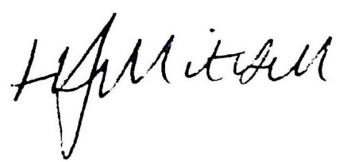

Andrew Farrow
Chief Officer (Planning & Environment)
Prif Swyddog Cynllunio a’r Amgylchedd

